Quality Assurance

Quality Assurance is a skill one does not have the ability to turn off once acquired. These are real world examples I found in my job search. This document provides real world examples of issues found in my job search. These are examples I have posted on LinkedIn. They are meant as examples of what needs to be fixed and continuous improvements.
Table of Contents

Incorrect Password Loop. 2
Didn’t You Already Apply to This Job? 3
“22 Errors and I Have No Job” 5
Philippines vs. Philly 9
“Oh SAP, You’re So Fine!” 13
Blanking Out 15
Kudos! 16
Curiosity Activated 17
no-reply@us.greenhouse-mail.io 26

Incorrect Password Loop.
From a LinkedIn post I made.

QA is my life. I was trying to apply to a job. I got stuck in a loop of "Incorrect username or password" and given a[n] error code a few times. I was sent to a Zendesk site. There were FAQ pages, but no form to provide a help request or report an error code.
The job I was applying for? Implementation Specialist.
Only in QA can you fit the description of "insanity is doing the same thing over and over and expecting a different result" and know it's okay to do so in order to provide proper feedback.

Why I mentioned this: A person trying to apply for a job will get frustrated by the inability to be able to apply. A person that wants to provide feedback is unable to provide feedback. In the end, the company searching for an employee is not getting the feedback requested.

Didn’t You Already Apply to This Job?
LinkedIn Post
I am trying to apply to a Business Systems Analyst (Requirements & Testing) position with Totara and from the user perspective, this one is getting to me. The form is powered by Breezy HR.
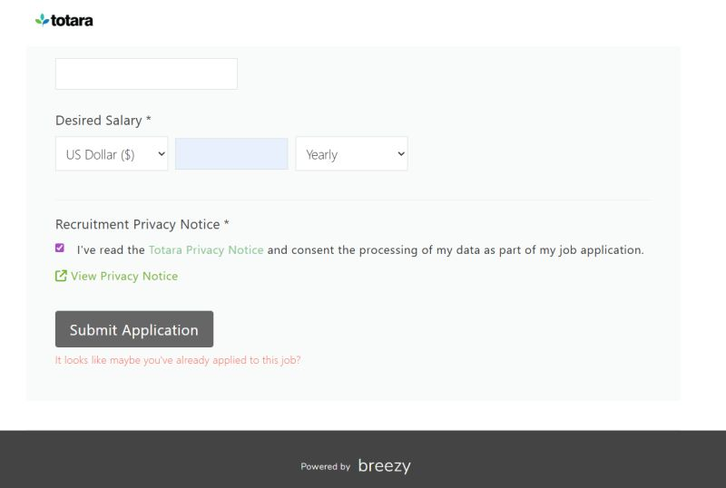
I do believe I applied for a role with this company in the past, but I think it was mid-2025. Never this role.
I filled in the application, making sure to change my details. On my **FIRST** upload attempted, I got the "It looks like maybe you've already applied to this job?" error message.
Why am I getting this? And if they are so sure I applied in the past, it would be nice to give me a few more details.
I took a look at the source code of the page. It's JAVAScript again. I saw this part:
<div ng-show="formSubmitted &amp;&amp; form.$invalid || sectionSubmitted" class="ng-hide error-container">
<span class="error polygot">%ERROR_INVALID_FORM%</span>
</div>
<div ng-if="errorMessage" class="error-container">
<span class="error">{{ errorMessage }}</span>

Nothing I can see at the moment to see what the input is to determine what causes the attempt to be invalid. Also, is %ERROR_INVALID_FORM% is static or dynamic variable? That would also determine errorMessage. They should have a primary-secondary relationship where the message is dependent on the error.
Is there a default error? Is the default error just "It looks like maybe you've already applied to this job?" How many applicants hit this issue and just said "Nope."
Yes, with my quality acceptance background, this puzzles me and it irritates me. I kept hitting the error even as [I] change my inputs to the form.

And the required follow-up post:
As a follow-up to this post from below, a member of the Totara team reached out to me to let me know they are going to pass on this issue to Breezy.
That makes me happy. Even if I don't get a position, it shows me they value the feedback. That's what QA is about.

Why I mentioned this: A person trying to apply for a job will get frustrated by the inability to be able to apply. I wasn’t certain what caused this error, but it’s presumption that this form stopped from applying that irritated me.
A Totara member saw my post and reached out to me to get a copy of my resume and stated she would contact the hiring software system company, Breezy about the issue. I appreciate the fact she reached out to me and took the opportunity to pass on an issue.

“22 Errors and I Have No Job”
LinkedIn Post
Maybe a recruiter or the hiring team of a company can use my LinkedIn account as a resume because I found another QA Analyst role to apply to that had an issue with the application process. Who knew I would play Quality Assurance Analyst just to fill out a job application!
Today's unlucky contestants: Paycom and Allied Benefit Systems.
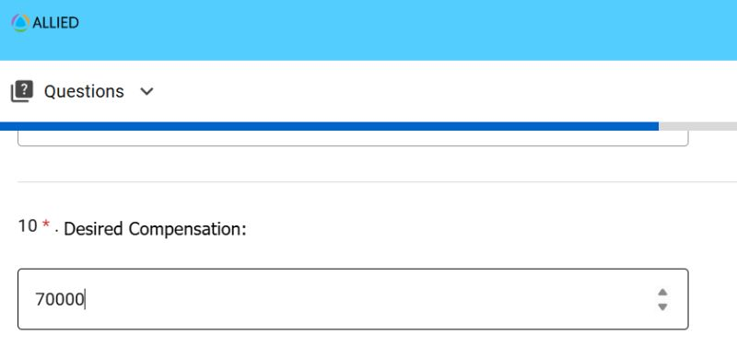
From the first screenshot: The Desired Compensation Box is a confusing mess. It asks for a number, but it does not state if the income is an annual amount or an hourly amount. This is why it's important: Exempt vs. Non-Exempt status. I was an Exempt employee, so my mind has a fixed annual rate flowing in my mind. Non-Exempt employees think in a rate of per hour, since they are normally paid hourly. By not clarifying what rate the amount is for, I can honestly see a person put 16 into the box.
The point of this irritation? Assume that the user needs clarification. I hate having to stoop to the lowest common denominator of intelligence with developing a system, but this is an example why the LCD is important.
The second screenshot is what really bothered me. When I uploaded my resume, it asked did I want to auto-fill the application. Sure, I will! Let's save some time. I noticed some errors in the auto-fill and manually updated the issues. I made the corrections and also declined to fill out the Tax Credit Questionnaire. When I hit submit, I got 22 error messages returned, saying the items were blank.
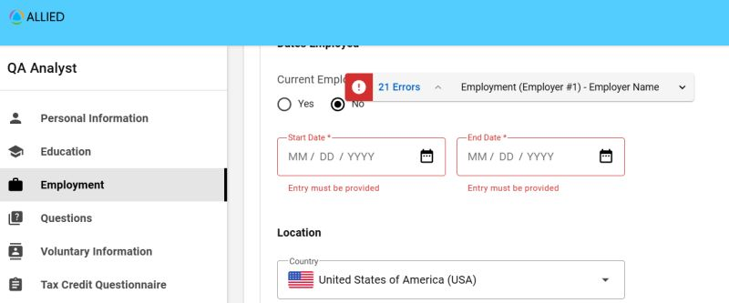
*bangs head on laptop*
I'm not sure if it the manual updates I made did it or the Tax Credit Questionnaire, but the pre-filled information from my resume was wiped out. My gut says the manual updates did. None of it carried over into the submission when I hit the submit button. 22 error[s] hit on all the items I didn't change.
HOW DID THIS GET INTO PRODUCTION?
As the end user, I expected the pre-filled data from my resume I did not touch to be left alone. A change in the Job Duties text box should not blank out the Employer Name text box. And if it does, it needs to be seen by the user. I would have noticed a red box if the variable was cleared externally on the user side.
I decided not to apply for the job. I am not paid to find these issues or fix these issue[s] and I don't want to fill in manually all the inputs again.
QA testing isn't just about how the coders want a system to work. QA testing is about reconciling the coders' system to work as their client needs it to work AND be used properly by the end user.
Note to recruiters and hiring teams: I write these post[s] from the perspective of the end user myself and not as a QA analyst. I'm formal with the documentation in a QA role. End user reports are not as friendly as formal QA reports.

There was a short follow-up to job application:
A follow up to the Allied Benefit Systems job application:
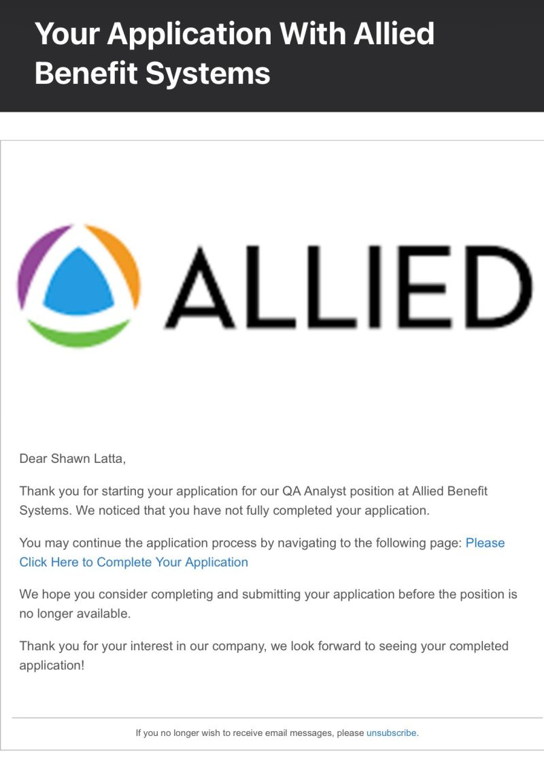

Why I mentioned this: One of the common complaints I see from job seekers is the need to upload a resume and then reinsert the resume data. This system did a great job of uploading the resume in the correct data inputs. My issue with it was that when I made corrections to the upload data, any other data was removed from the form’s parameters on the back end. I saw on my screen my employer names, but when I hit the submit button, that parameter was null. The errors caught the nulls as expected. The fact they became nulls to begin with was my issue.
I was so frustrated by the 22 errors; I didn’t complete the application at the time. The system was able to send me a reminder email.
The mention of the salary box was more of a user interface (UX) issue. As part of my QA testing skills, I notice items that may cause confusion. As I explained above, the annual salary varies based on how a person is paid.

Philippines vs. Philly
LinkedIn Post
This entry is not so much a QA issue as it is an issue of a misleading post. There is some QA in it, but more of my analysis of another poor job application.
I saw a Manual QA Analyst job listed on LinkedIn. In Image 1, it says United States in the search and it's remote. Okay, cool. I hit the Apply Button.
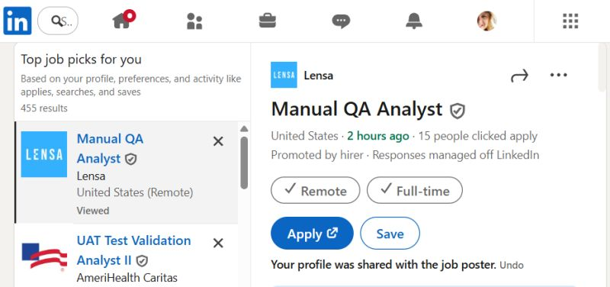

Image 2 is the Lensa page about the job. Nothing about location. Clicking on the Manual QA Analyst link takes me to the CAI page. Image 3 states the job is a remote job out of PHL. I hit the apply now button.
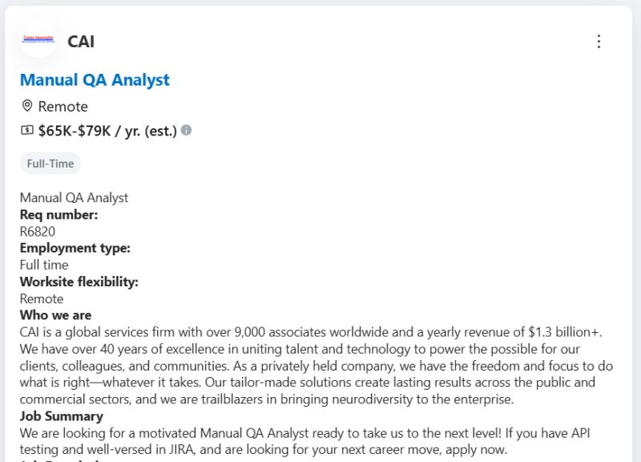
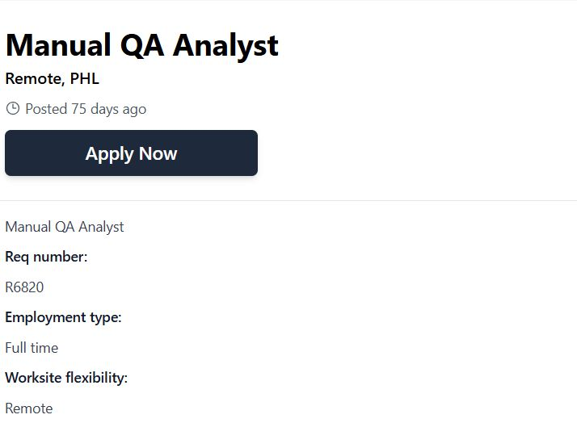

Image 4 is another page with an apply now button. However, this page tells me the job is in the Philippines.
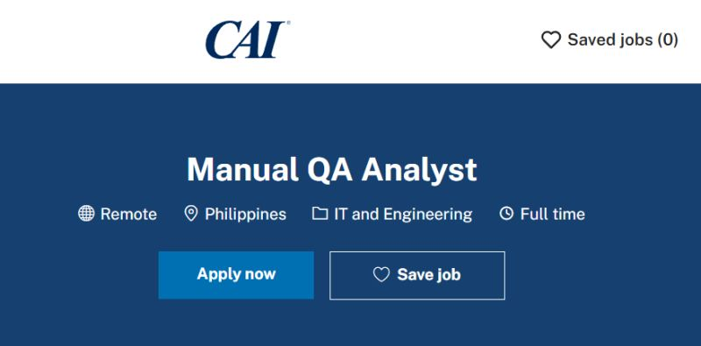
Where did this disconnect come from? How did a job in the Philippines get suggested to me as a job in the USA?
From what I have read, Lensa is a specific clearinghouse for job listings. It works like an Internet Robot seeking jobs. Then, those job postings end up on LinkedIn and other sites. No different that Google running across webpages to catalogue different sites. CAI has every right to run a job listing for a job in the Philippines.
However, I think I can understand what happened. The ISO 3166-1 alpha-3 code for the nation of the Philippines is PHL. In the US, PHL is also a common abbreviation by some for the city of Philadelphia, PA. After all, the IATA code for Philadelphia International Airport is PHL.
I think Lensa's computer found the PHL and parsed it as a job in Philly, so the job was determined to be a US-based job. That makes me wonder was it coded to review ISO 3166-1 alpha-3 or IATA codes to determine a location. I'm a geography nerd, if you wonder. That's how I know about ISO 3166-1 alpha-3 and IATA codes. If IATA is used over ISO, then I can see AUS parsing for Austin, TX for Australia, IND parsing Indianapolis, IN over India, and MCO parsing as Orlando, FL when in ISO, it's Monaco.
At the end of it all, I'm disappointed that an interesting position ended up being in the Philippines. The moral of the post? Watch how things are parsed by your system. Even if my analysis is wrong, everyone should validate how codes are parsed.

Why I mentioned this: This is an issue that is irritating. There should be no reason such a huge disconnect should happen. I don’t know where the bad code translation occurred. It reminded me of the Telephone Game played as a child. What is said at the beginning is not what you hear at the end.
Philadelphia is located at 39.9526° N, 75.1652° W. Cebu, Philippines is at 10.2926° N, 123.9022° E. Map them and you will see the difference.
That's why, for certain jobs I'm interested in, I apply directly through the company's website and check their available locations.

“Oh SAP, You’re So Fine!”
LinkedIn Post
Ok, Aflac / SAP SuccessFactors, it's your turn for my Quality Assurance analysis.
I'm filling out an application and the flow of the inputs looks odd to me. My display is at 1920 x 1080 pixels. The question about previous employment is on one side of the screen, opposite of the question about further details of previous employment. It caught me off guard for a moment.
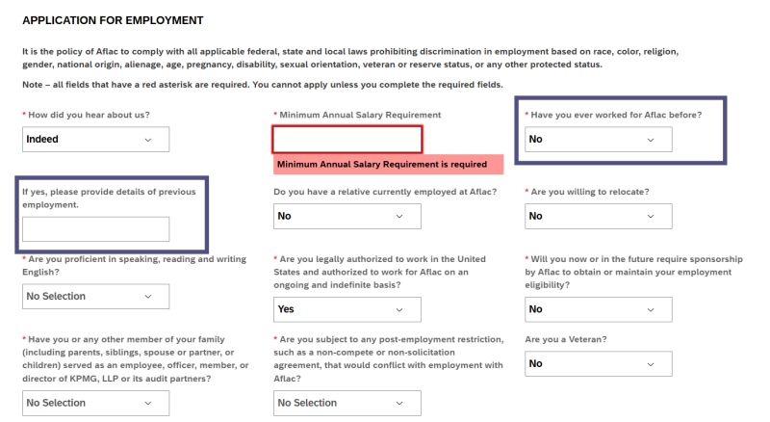

The design works if the person making the inputs is using the tab key between input boxes. How many people use the tab key in this scenario? I can't assume everyone is using the tab key.
To be able to use the tab key and have the 2 prior employment questions together, I would move 3 questions: Move the Worked For question to where the Minimum Salary is. Worked for would be replaced by If Yes, and Minimum Salary would be placed were If Yes is now. Tab users and mouse users have a logical flow both ways.
Personally, I think the question about a family member working for Aflac should be associated with the personal Aflac employment question. My reasoning for that is it's disruptive to the thought flow of employment history.
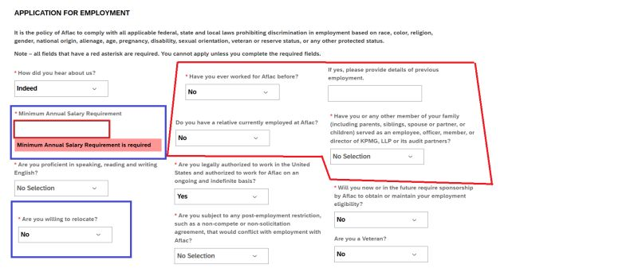
In my real QA documentation I would send back to my developer or write up as an enhancement, I would also show an illustration of what would make things easier. I don't have the UX training for the psychology of design. I just provide feedback as the end user.

Why I mentioned this: I call out the company I’m applying and the company for the software they are using to process the application when I see an issue. I don’t know which company is coding the back end, so I let both know. When I was working on this application, I was taken aback by the location of the questions. I don’t use the tab button when I am working on a new application, be it a job application or a web coding interface. I have to reconcile form and function with a new form. Once I know what the interface is like and mapped in my mind, using the tab button works.
In good news, SAP SuccessFactors saw my post from my tagging them and thanked me for the feedback with continuous improvement in mind.

Blanking Out
LinkedIn Post
Someone should hire me to be a QA on their Workday setup. This is NOT the first time I have seen a blank Skills section in a job application.
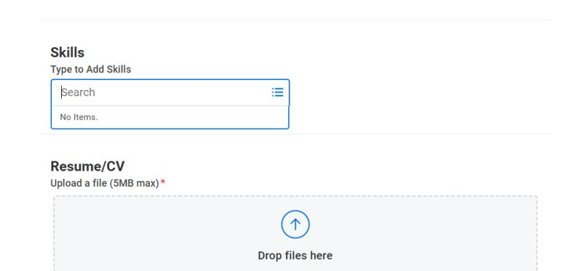

Is there not a toggle in the Workday backend to turn this module off if you aren't going to use it[?] [I]s there a toggle to have the availability to allow the user to add their own inputs? Can't someone feed acceptable values in the database tables for what the employer expects?

Why I mentioned this: This issue is a disservice to the applicant. The employer wants to know your skills and place them into the Workday database. As a part of the ability to run a SQL query for a skill, provided the search parameters are correct, is the ability to run a quick search to find a person that has that wanted skill.
Looking for a person that has applied and has the skill of premium processing? The backend database is going to be empty. If a company has a robust AI system or they have a setup to automate filling in the skills backend, or you don’t want to use such a table, then toggle the unused feature off.
Like they say on Chopped to the contestants – unless an item has a functionality in a meal, don’t place it on a plate. That same sentiment is needed with user interfaces and interactions as well.

Kudos!
LinkedIn Post
Last week, I had mentioned an application had an unclear salary box. That system was using Paycom. I thought it was user unfriendly.
Today, I applied for a job using the ADP system. It had the salary box the Paycom system should have had.
Pictured are the examples to compare. The ADP application solves the question on an annual amount or an hourly amount thought a person has when reflecting on their salary. As an exempt employee in the past, my brain thinks of my pay in annual terms. When I was a kid working with no degree, I was non-exempt and thought of my pay in the $8.00 an hour it was.
 | 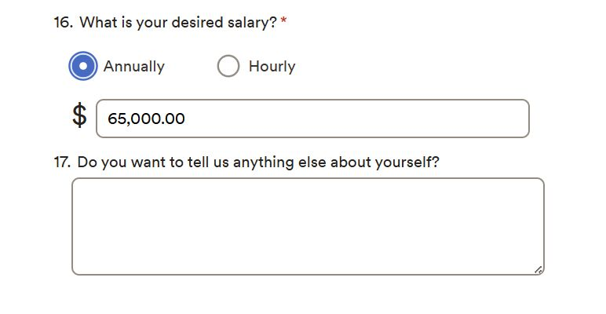
For me as the applicant, I am not concerned on the backend of the application is like. I don't really care for what ADP does for its customer compares to Paycom and its customer base. In this example, the main thing as the end user is having a clear and friendly question about my salary requirements.
As a system analyst, I find myself wondering if the systems are maintained and updated by the client or the SaaS provider.
Why I mentioned this: Besides talking about issues, I like to thank companies that make things easier for the end user. Comparing and contrasting interfaces is part of QA. What little nuances make the difference? That’s all this post was about.

Curiosity Activated
LinkedIn Post
Another day, another rejection. While this post sounds like sour grapes, you never know what you can discover when you're trying to research WHY the grapes are sour.
So, in my quest to find a new job, I find myself wanting and questioning the WHY I'm rejected. Waking up first thing to see another rejection letter in my inbox just broke my heart again.
Today's unlucky business is OneDigital. At this point, I kind of figured I wouldn't get the job. However, going through the process was the part it what I was interested in.

Part One — The Application
The application part was pretty much a standard Workday application. Upload your resume; cut and paste the application because items didn't appear or were placed in the wrong box. All that fun stuff.
However at the end of the application was this box about using AI:
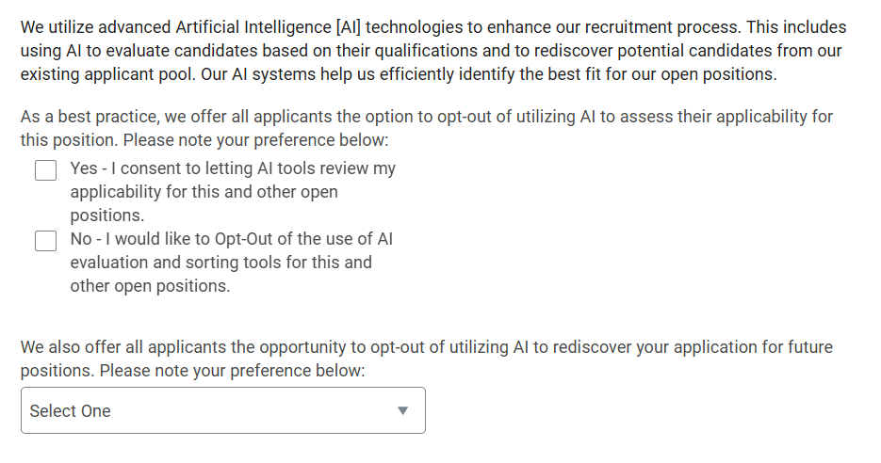
This time, I actually opted in. I wanted to see the rejection results.
After completing the application, including the required cutting and pasting, I was sent a confirmation email:
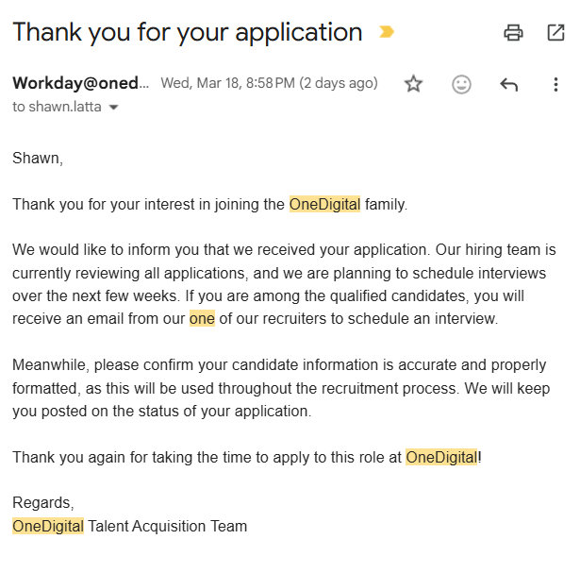
Personally, it would have been nice if this form letter had been coded with a variable to insert the job title and requisition number in it. When you apply for so many jobs, you start to lose track of what you applied to. Funny, the job title and requisition number were in the rejection letter. Speaking of the rejection letter:
Part Two — The Rejection
My confirmation letter was sent on Wed, Mar 18, 8:58 PM. My rejection letter was sent at at 12:23 AM Fri, Mar 20.
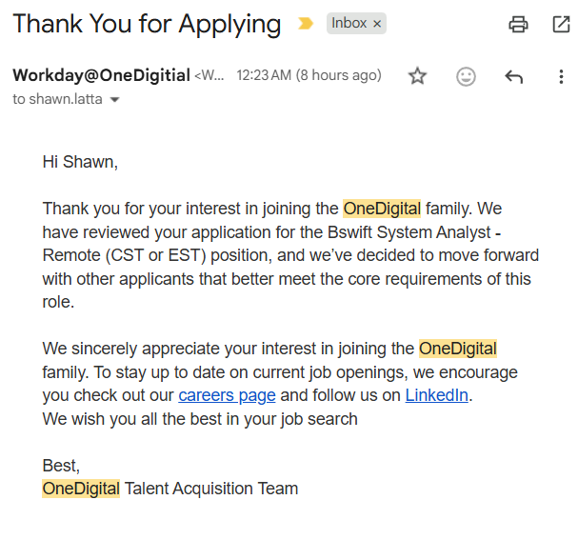

It was a pretty intensive resume, so I doubt a human saw it. AI looked it over. Like the good little data analyst and curious person I am, I'm wondering what were the parameters for a rejection.
First, the list of Qualifications, Skills and Requirements:
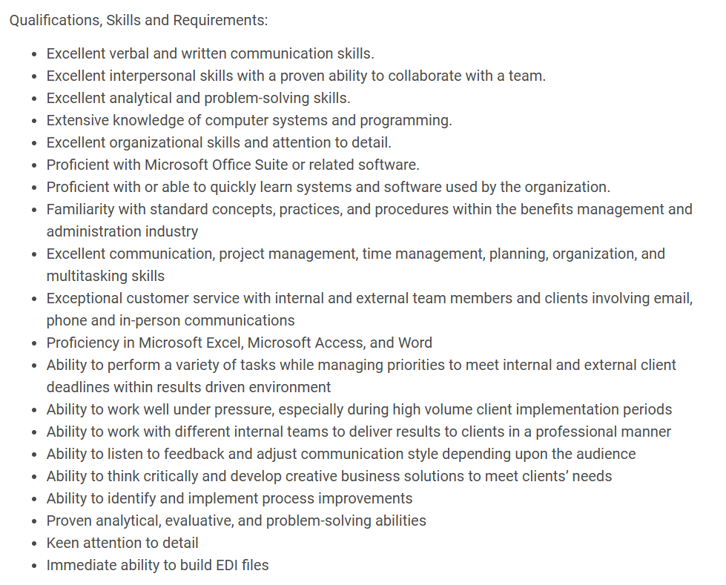
Honestly, many of these items are hard and odd to quantify.
- Ability to work well under pressure, especially during high volume client implementation periods
If I was able to speak to a human about this application, I could tell you that I was ALWAYS in an annual enrollment state of mind. My client at one point had 2 annual enrollments each year. As soon as one AE closed, it was off to code their other AE. AE had strict deadlines.
In the application, I had placed "Supported UAT activities and served as SME for COBRA, annual enrollment, and retirees/Medicare workflows across enterprise health and welfare accounts."
Also mentioned in the application was "Led 1095-C employer reporting implementation for multiple clients, serving as subject matter expert for system development and ACA compliance validation."
I worked SO many hours on 1095-C, my lead made sure I didn't lose my use-it-or-lose it PTO just to get the project done on time. However, that is a topic that is only discovered by talking about a project. If I can survive that, I have the "Ability to work well under pressure, especially during high volume client implementation periods."
- Proficient with or able to quickly learn systems and software used by the organization.
I can learn systems. The requirement has the word OR. If a company really wants a person to know the system, do not use the word OR.
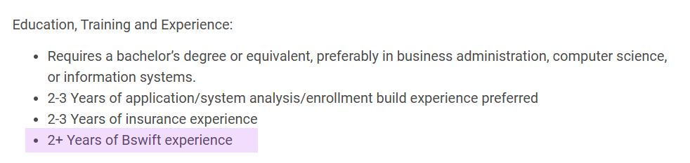
The system used by OneDigital - bswift:

insert Charlie Brown screaming here
In my postmortem of my rejection, Bswift was the only thing lacking in my resume! HOW DARE I NOT HAVE TWO YEARS OF EXPERIENCE WITH BSWIFT! I must be useless! I can't do this job. My years at Alight Solutions are meaningless because I don't have the 2 years experience of Bswift.
This brings me to circle back around to the AI aspect. What was the factor that said I wasn't suited for the job. What was the core skill? What was the magic word missing in my resume?
I don't blame a company for wanting an AI filter for a job application. I understand screening a resume to take out all the persons that aren't qualified. Screen out the plumbers and the mechanics that are applying for a System Analyst role if they have no related skills.
However, where I am getting frustrated with is the minutiae of it now. I can meet every qualification or requirement, but because I don't have certain experiences with certain software, it makes me unqualified according to AI and a bunch or poor queries. I am starting to regret all my years at Alight Solutions and working on their proprietary systems.
I do thank the few recruiters that have take[n] the time to speak with me in order to fill a role. I thank them because they were the few that could look at my resume and experience and understand it. While I may not have gotten the role they were trying to place me in, they knew what my experience is and could try to show these companies what I really offer. They could determine something a computer can't.
I guess for next time, if an application asks for Bswift, I'll just mentioned the phrase "Bswift Competitor." If the system wants to see a word, they'll see that word.
I've spoken enough, but this last part is for all my friends in QA and hitting errors. Why do I always seem to be the one to hit the errors?

Part Three — The Research
As part of the rejection debrief, I had to log into the OneDigital Workday portal. I started an application to review the AI part again. After getting the required screenshots, I went to the Candidate Home to delete the application:
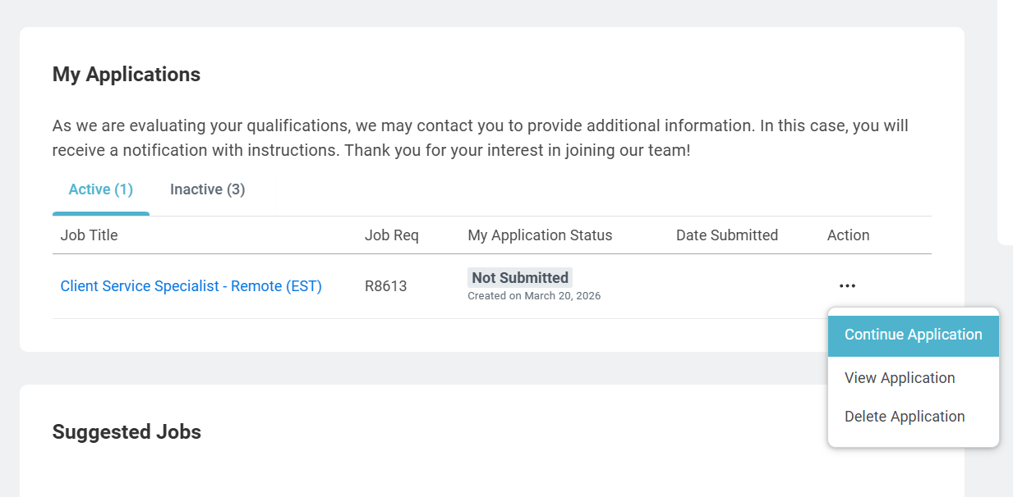
I would have liked a small trash can under the action column for a quick delete, but that's negligible. It's just a second or 2 more to click for a drop down to click on Delete Application.

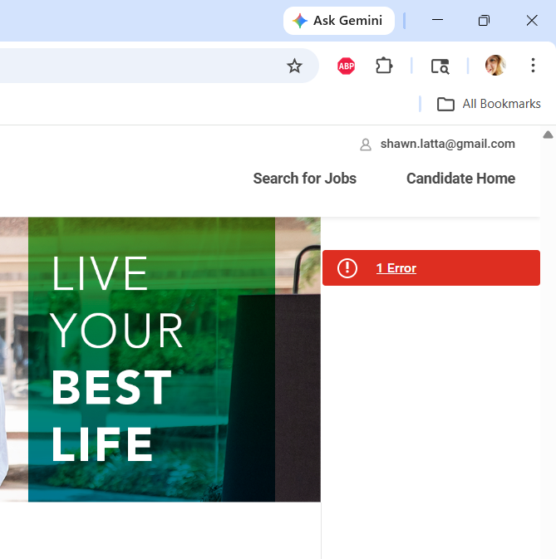
WHY AM I GETTING A[N] ERROR?
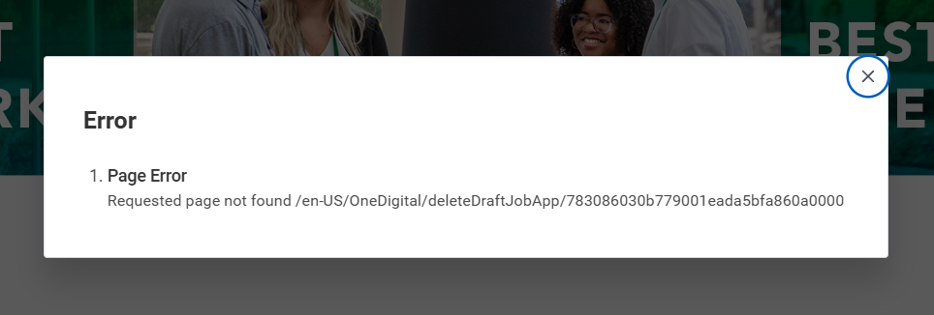
What?
Requested page not found /en-US/OneDigital/deleteDraftJobApp/783086030b779001eada5bfa860a0000
I've tried it a few times now. I CAN'T DELETE THE DRAFT!
Oh the humor in this! I need a job. I have a background in QA in benefits administration technology with Alight Solutions. I applied for a job with a company for such a role. OneDigital use a Workday platform for the HR needs, but also uses bswift, an Alight competitor. I get turned down for a role. I inspect the application process by starting another application meant for deletion and I CAN NOT DELETE THE DRAFT!
I can't even do the most simple of items in the whole #TalentAcquisition domain of DELETING A DRAFT APPLICATION! But I'm not qualified for a role to do QA or be a business analyst?

Why I mentioned this: I was in a disappointed mood due to getting another rejection. I decided to do a self-debrief on what I could have done wrong.
During my review, I noticed 2 lines that were contradictory to me and it set off my Writing Center skills. The requirements of the job description had semantics that didn’t align with each other. One line asked for the ability “to quickly learn systems and software used by the organization” whereas another requirement is “2+ years of Bswift experience.”
The wording and structure of the description is discombobulated. I know the job title is for Bswift, but with contradictory terms, the title tells candidates they are working with Bswift. If the role being filled is with an external company, like a recruiting company would do, then organization is not specific enough. Using a term like external organization would convey a better understanding of the requirements. It’s not OneDigital that requires the learning capabilities. It’s the company they are headhunting for.
As is written, the term organization could also apply to employment with the listing company, or in this case, OneDigital. That’s ambiguous. In this context, Bswift is a system used by OneDigital. With the wording above, there are 2 possible interpretations:
- You can quickly pick up a system/software package
- Or you know 2+ years of Bswift.
The job application needs clear, distinct, and proper terminology.
These job requirements would be cleaner if written in one of these following ways:
- Proficient with or able to quickly learn systems and software used by the external organization. Two years+ experience of Bswift is a plus.
This conveys the notion that while Bswift experience is not needed, having it would make a candidate more attractive.
- Two years+ experience of Bwift in addition to being proficient with or able to quickly learn systems and software used by the external organization.
This phrasing makes it clear that you must have the Bswift experience and show the capability to learn additional software/systems.
- Do not use the phrase “Proficient with or able to quickly learn systems and software used by the organization.”
Use only the Bswift line. Probably the least palatable wording, but acceptable in making this knowledge the main priority.
- Do not use the phrase “2+ years of Bswift experience.”
The proficiency line should be enough. If you can learn systems, you should be able to learn Bswift on the fly like the phrase “quickly learn” would cover.

I also take umbrage at the lack of other software and systems used for this role.
The other issue I found was the inability to delete the application. Looks to be a Workday issue. It’s just bad optics, especially next to the “LIVE YOUR BEST LIFE” line. Also, since it’s a job for a HRIS benefits system using another HRIS system rejecting a person employed using a second HRIS benefits system, seeing such a Tier One error just made me laugh at the irony of it all.

no-reply@us.greenhouse-mail.io
LinkedIn Post
Not mentioned in this documentation, I create a post discussing Business English rules broken in a few rejection letters. Proofreading is a form of QA with communications. As part of that break down, I noticed I had several rejection letters in my inbox that only had no-reply@us.greenhouse-mail.io
This post is about getting an answering an answer about the no-reply@us.greenhouse-mail.io email,
I just want to thank TechnologyAdvice for rejecting my application. Their rejection letter shows me that Greenhouse Software rejection letters can be customized. They did not use the "more align" wording in the rejection. I was wondering about customization last week. Now that question is answered.
However, I do have a new concern about all my rejections letters via Greenhouse. Is the Greenhouse system set to have all emails sent from the platform to only have no-reply@us.greenhouse-mail.io as the identifier? Can they not customize the name of the sender the no-reply address is representing?
And yes, that's my inbox and all those companies have rejected me using Greenhouse alone. I also have rejections from people that use Workday. Is there any wonder why I feel unseen and unwanted? Any wonder why I question the filters used by these companies?
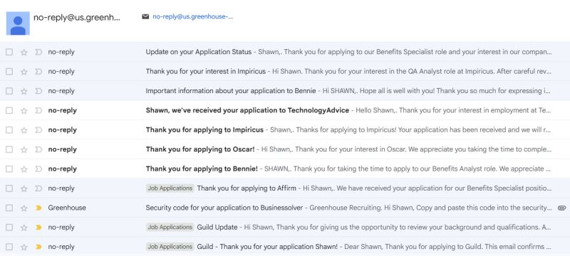
Why I mentioned this: At a glance, there is no way to know what company using Greenhouse sent me a e-mail within the Name and Address column. I have to look into the subject and/or email to know if it’s worth my time. When time can be of the essence, this can slow you down while looking for an email.

